PROMPT:
Dear Statisticians:
Thank you so much for helping me with this project. Your professor has highly recommended you, so I am confident that you will do a great job with analyzing my data. Let me tell you a little bit about myself. I am a young entrepreneur trying to create my own startup company. I won the Young Entrepreneur award last year in high school. Im often told that I have a good head for business. With this in mind, I have raised over $100,000 through Kickstarter and am ready to turn it into quick and easy profit.
Online dating is a growing industry with recent quarterly profits well in excess of millions. My goal is to break into this industry with my new site PIZZAZ.COM that uses the power of statistics to optimally match couples. To help with this I recently hosted a speed dating event where 276 couples were randomly paired up with one another for a short speed date. For this particular event, I only considered male-female pairings. Each line of the dataset corresponds to a “date”, which is a 4-5 minute interaction between the male and female. Although each participant engaged in multiple such dates the simplified dataset that I am giving you only includes first dates.
I have spoken with your professor and communicated with him the information that I am looking for. He has agreed to write an exam that will simultaneously test your knowledge of categorical analysis while also gathering a wealth of profitable information!!!
It is unfortunate that we will not be able to meet in person. However, I am confident that your professor will pass the relevant information to me. If there are any issues or questions, your professor has been kind enough to let me use his e-mail account for the next couple of weeks.

Until then remember that time is $$$, friend!

--Entrepreneur Jim

SECTION ONE – VARIABLE CREATION:
1a) Online profiles generally put ages into categories rather than giving the actual age. With this in mind we turn each age variable (Male and Female) into a variable called AgeGroupM (For males) and AgeGroupF (For females).

For participants that are 23 or younger code their group age as “Younger”.
For participants that are 24-29 code their age group as “Average”.
For participants that are 30 or older code their age group as “Older”.

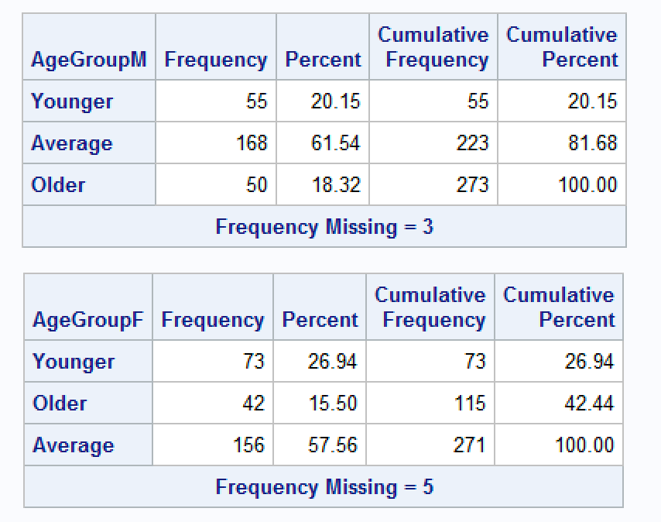
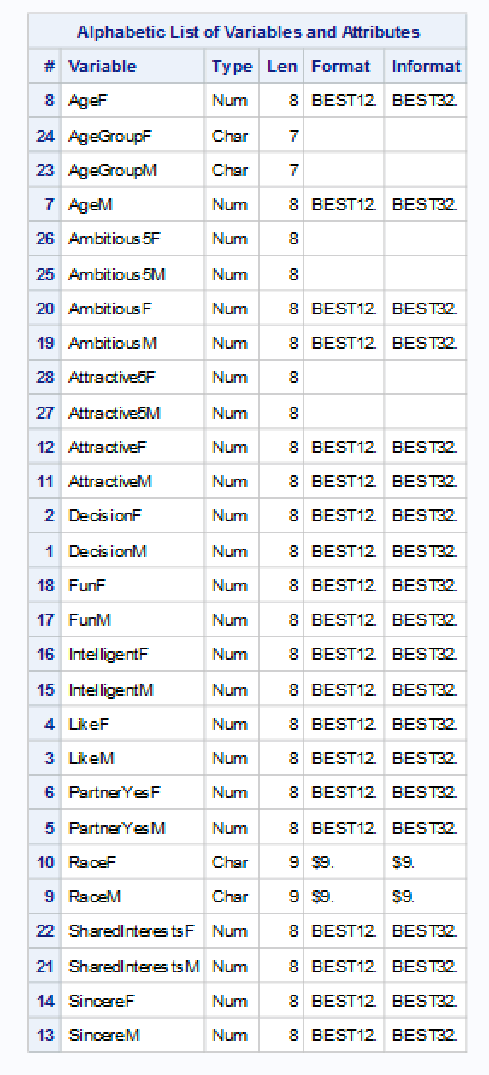
1b) Entrepreneur Jim is interested in testing 5 pt scales rather than 10 pt scales. To help him we should create new variables
Attractive5F and Attractive5M as well as Ambitious5F and Ambitious5M.
If the original variable is 1-2 then code the new one as a 1.
If the original variable is 3-4 then code the new one as a 2.
If the original variable is 5-6 then code the new one as a 3.
If the original variable is 7-8 then code the new one as a 4.
Finally, if the original variable is 9-10 then code the new one as a 5.

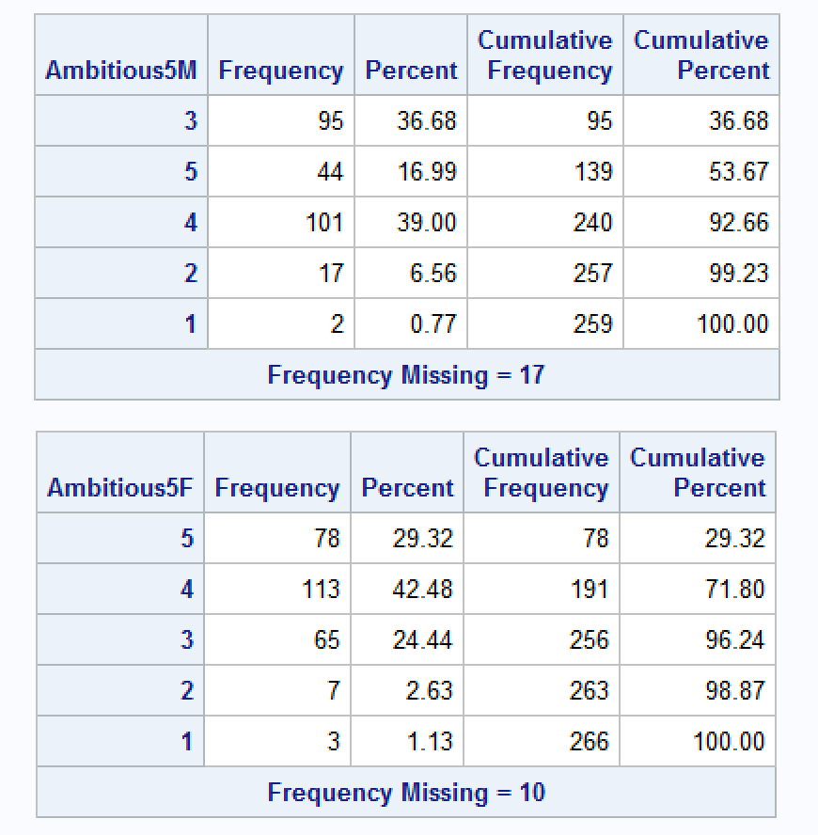
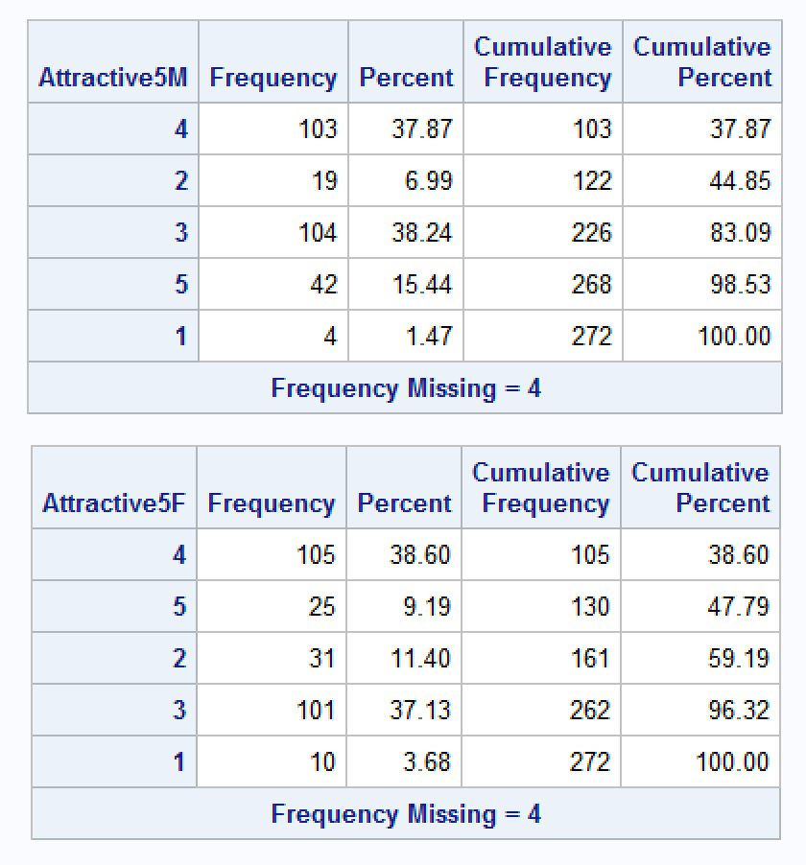

Note: Other variables may still need to be created.

SECTION TWO – TABLES
In order to test to see if there is a relationship between decision and sex, we ran the Pearson’s Chi^2 Test. The sample size is considered adequate to run the test if all expected cell counts are 5 or more. In Table 2a, it can be seen that this condition is met as all cell counts are over 5.

Our test statistic is 1.0234 with 1 degree since this is a 2x2 table (Table 2b). The p-value of our test statistic is 0.3117 which is well above our significance level of 0.05 so we conclude that there is no relationship between sex and decision.

Table 2a: Table 2b:
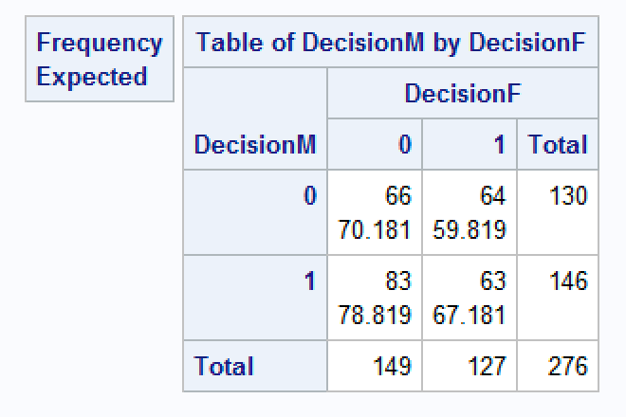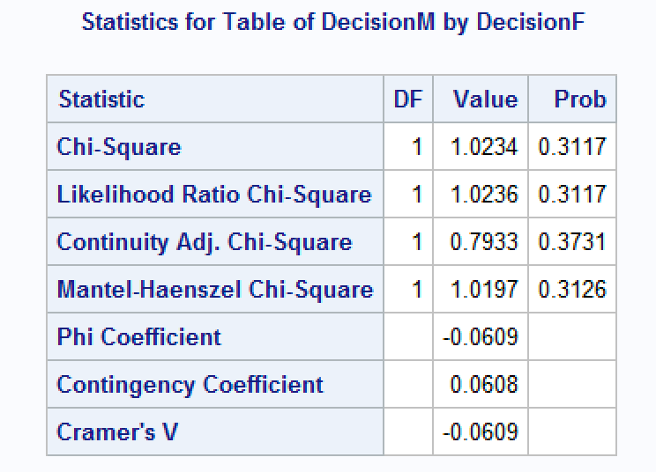

"Risk" ratio of males to females is 1.14 as seen in the Table 2c below which means the probability of wanting to see the date again for males is 1.14 times that of females.

Table 2c:
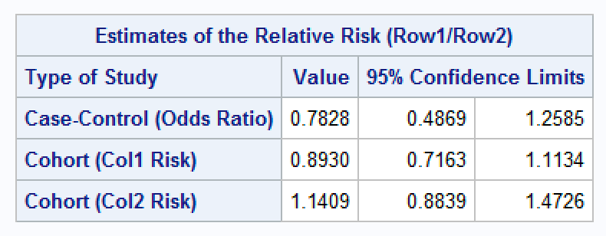

3) To test whether there a relationship between decision and sex after controlling for age (Using the age group variable), we use the Breslow Day Test for which at least 80% of expected cell counts need to be greater than 5 in all individual tables. This satisfied by the tables generated. Since the test statistic is 13.4225 with value of 0.0012 (Table 3b) which is less than 0.05, this means that we have to analyze each table separately since this test statistic is non-significant. This is done in question 4 below.
The common/adjusted odds ratio of males to females is 1.2930 (Table 3a). This means that the odds of males wanting to see their date again is 1.2930 times that of a female.
Table 3a: Table 3b:
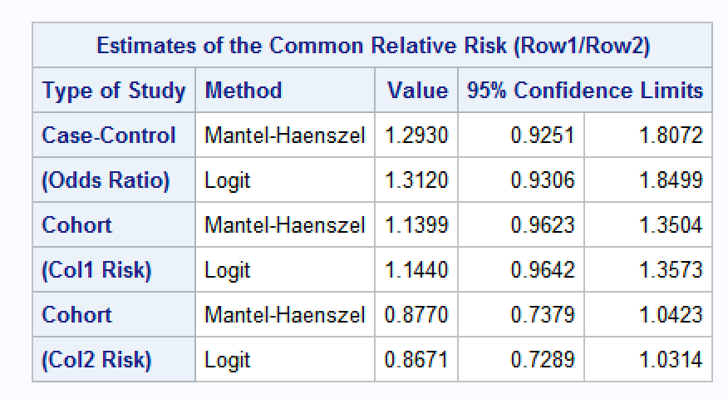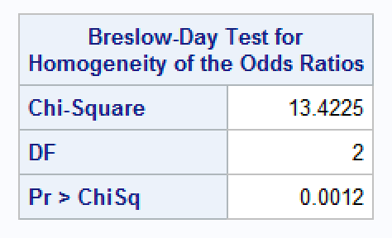

4) To Test whether there is the relationship between decision and sex the same across the three age groups, we analyze each table which is split by each age group: Younger, Average, Older as mentioned in above.
For age group younger, the test statistic is 5.8871 with a p-value of 0.0153 which is less than our significance level of 0.05 so we conclude that there is a significant relationship between age group younger and decision of either sex. (table 4a).
For age group Average, the test statistic is 3.2912 with a p-value of 0.0697 which is greater than our significance level of 0.05 so we conclude that there is not a significant relationship between age group average and decision of either sex. (table 4b).
For age group younger, the test statistic is 6.5051 with a p-value of 0.0108 which is less than our significance level of 0.05 so we conclude that there is a significant relationship between age group younger and decision of either sex. (table 4c).

Table 4a: Table 4b:
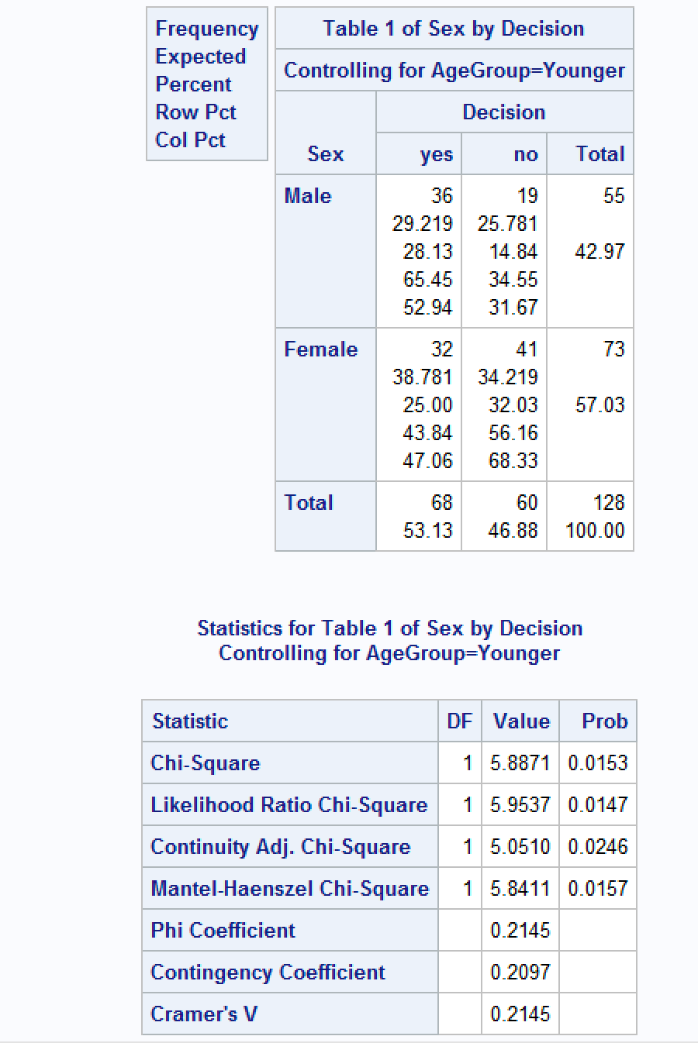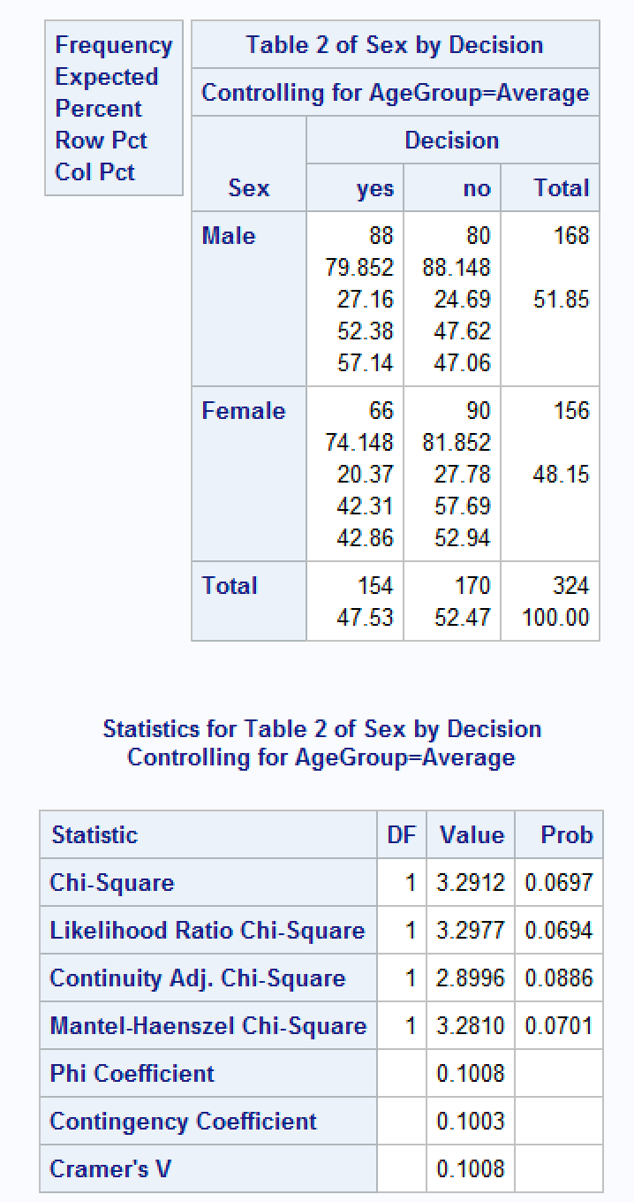

Table 4c:
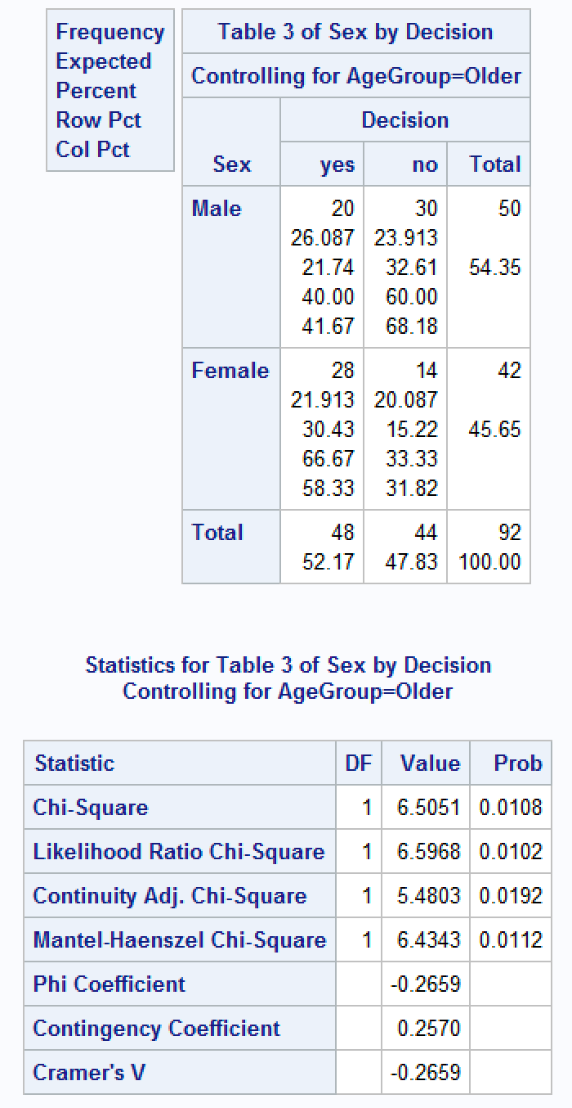

5) To test whether is there a relationship between race and age group while controlling for sex, we analyze as below:
Since there is one nominal and one ordinal variable, we use the row means test score. Since the variables don’t have an equal distance between categories, we use Modified Ridits for our scoring. Sample size is justified as the overall sample size is greater than 30 in each subset table. With test statistic of 1.5474 and p-value of 0.4613 which is greater than 0.05 significance level, there isn’t a significant relationship between race and age group controlling for sex.

Table 5:
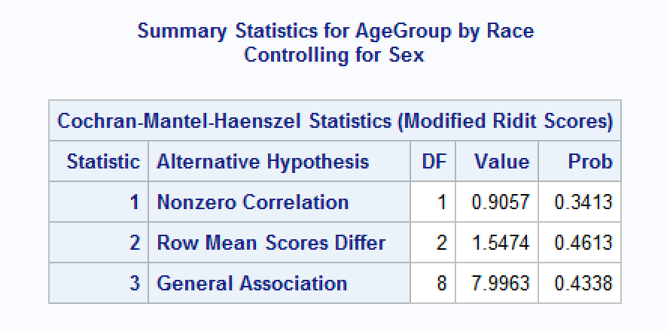
6) To test whether is there a relationship between age group and attractiveness (Using the 5 pt scale) controlling for sex, we analyze as below:
We use the Correlation Test to test the relationship. The sample size is sufficiently large since the total sample size is greater than 30.
H_{o}: There is no relationship between age group and attractiveness controlling for sex
H_{a}: There is a linear relationship between age group and attractiveness controlling for sex
Since the variables don’t have an equal distance between categories, we use Modified Ridits for our scoring. Sample size is justified as the overall sample size is 536 which is greater than 30. Test statistic of 1.4327 with 1 degree of freedom and p-value of 0.2313 which is greater than 0.05 significance level, there isn’t a significant relationship between race and age group controlling for sex. Hence, we fail to reject Ho which means that there is not a significant relationship between age group and attractiveness (5 pt scale) controlling for sex.

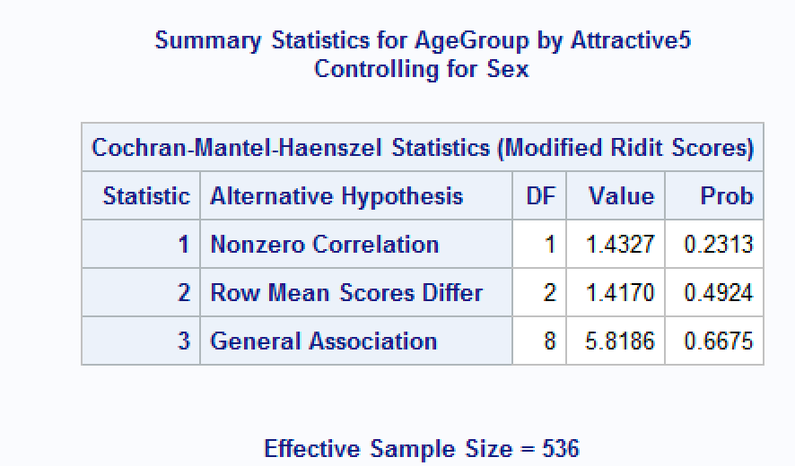

7) We say that there is a match if both male and female would like to see each other again. Below we test to see if there a relationship between there being a match and the male and female having the same race.
To test to see if there is a relationship between being a match and having the same race, we use the Chi square Test. The sample size for our dataset is 276 and all expected cell counts are larger than 5 which satisfies the sample size sufficiency.
The data was coded to create a new variable “match” and “same_race”. Match was created if both male and female would like to see each other again (both had decision = 1) as “yes” and not otherwise. “same_race” was created if both male and female had the same race.
Since the test statistic is 0.5696 and p-value is 0.4504(table 7) which is well above our usual threshold of 0.05, so we conclude there is no relationship between being a match and the male and female having the same race.
Table 7:
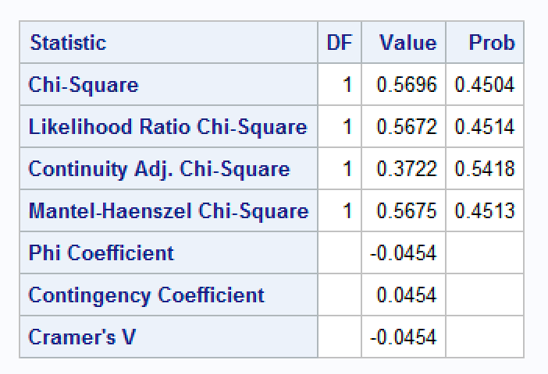
SECTION THREE -- LOGISTIC REGRESSION
8) Setting up an appropriate logistic regression model to test whether or not a male participant's decision depends on their age group. Using reference parameterization with Younger as the reference category. We write out our model equation below:
Using Younger as the reference category (Table 8b), the following model equation is obtained from Table 8a.

Logit(pie(X))hat = 0.6390 – 0.5437X_{AverageAgeGroup} – 1.0445X_{OlderAgeGroup}
Where X_{AverageAgeGroup} = 1 if Average and 0 otherwise
Where X_{OlderAgeGroup} = 1 if Average and 0 otherwise

Since the P-value for AgeGroupM Older (0.0098) is less than significance value of 0.05, it is significant while Average (0.0922) is not (See Table 8a)

Table 8a: Table 8b:
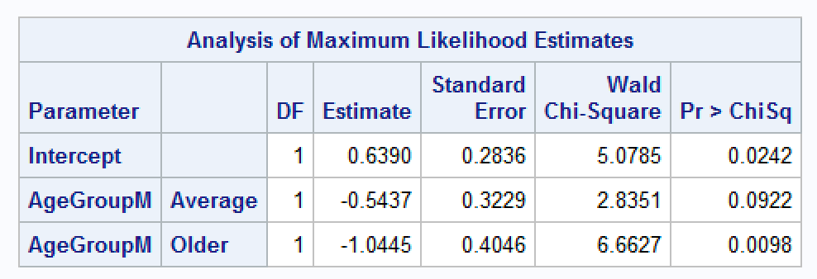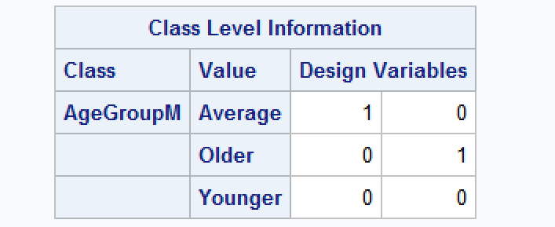

The odds of a male in the average age group to have a decision of “yes” to want to go another date is 1.65 times that of a female in age group Older. While the odds of a male in the average age group to have a decision of “yes” is 0.581 times that of a male in age group Younger. The odds of a male in the older age group to have a decision of “yes” is 0.352 times that of a male in age group Younger. These can be observed in Table 8c.

Table 8c:
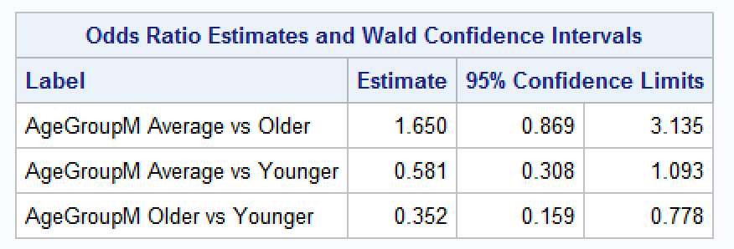

8a) The probability that a young male participant wants to have another date is 65%. The probability that an average-aged male participant wants to have another date 52.7%. The probability that an older-aged male participant wants to have another date is 37%. These figures can be seen in Table 8a-a below.
Table 8a-a:
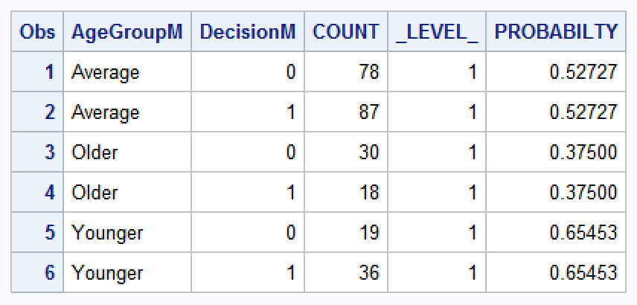

9) Setting up an appropriate logistic regression model to test whether or not a female participant's decision depends on their age group. Using reference parameterization with Younger as the reference category. We write out our model equation below:
Using Younger as the reference category (Table 9b), the following model equation is obtained from Table 9a.

Logit(pie(X))hat = – 0.2478 – 0.0623X_{AverageAgeGroup} + 0.9409X_{OlderAgeGroup}
Where X_{AverageAgeGroup} = 1 if Average and 0 otherwise
Where X_{OlderAgeGroup} = 1 if Average and 0 otherwise

Since the P-value for AgeGroupF Older (0.0197) is less than significance value of 0.05, it is significant while Average (0.8276) is not (See Table 9a)
Table 9a: Table 9b:
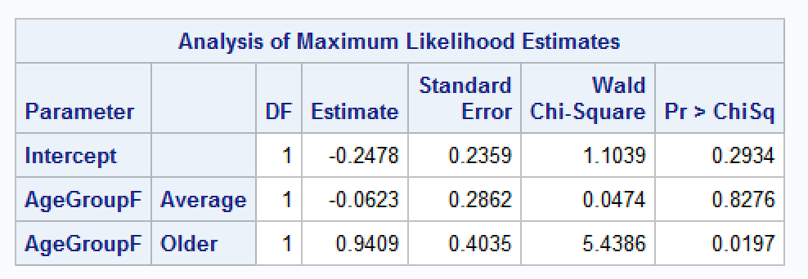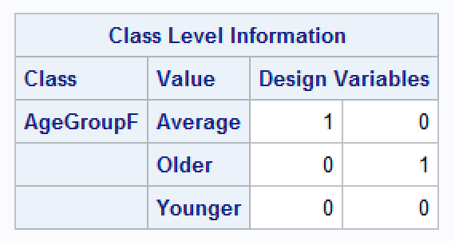
The odds of a female in the average age group to have a decision of “yes” to want to go another date is 0.37 times that of a female in age group Older. While the odds of a female in the average age group to have a decision of “yes” is 0.94 times that of a female in age group Younger. The odds of a female in the older age group to have a decision of “yes” is 2.562 times that of a female in age group Younger. These can be observed in Table 9c.
Table 9c:
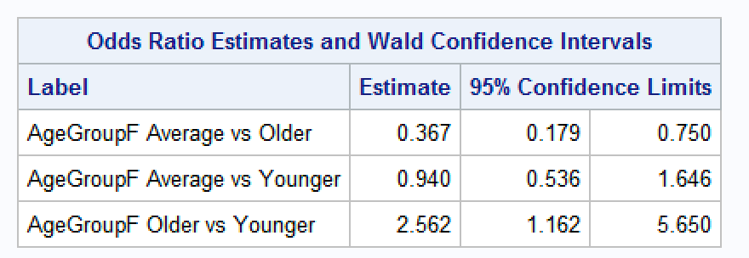
9a) The probability that a young female participant wants to have another date is 43.8%. The probability that an average-aged female participant wants to have another date 42%. The probability that an older-aged female participant wants to have another date is 66.6%. These figures can be seen in Table 9a-a below.
Table 9a-a:
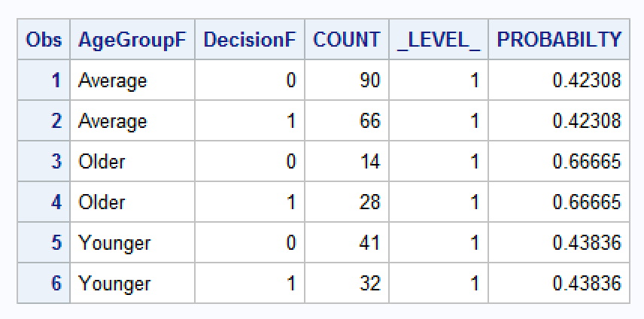
10) Based on the predicted values and results above, I expect there to be interaction between age and sex to be significant. As males get older they seem less likely to want a second date whereas when females get older they seem more likely to want a second date.

Model equation with age group, sex, and its interaction (Table10):
Logit(pie(X))hat = – 0.2478 – 0.0623X_{AverageAgeGroup} + 0.9409X_{OlderAgeGroup} + 0.8869X_{MaleSex}- 0. 4814X_{AverageAgeGroupSexMale} - 1.9853X_{OlderAgeGroupMale}
Where X_{AverageAgeGroup} = 1 if Average and 0 otherwise
Where X_{OlderAgeGroup} = 1 if Older and 0 otherwise
Where X_{MaleSex} = 1 if Male and 0 otherwise
Where X_{AverageAgeGroupSexMale} = 1 if Average and Male and 0 otherwise
Where X_{OlderAgeGroupSexMale} = 1 if Average and 0 otherwise

Table 10:
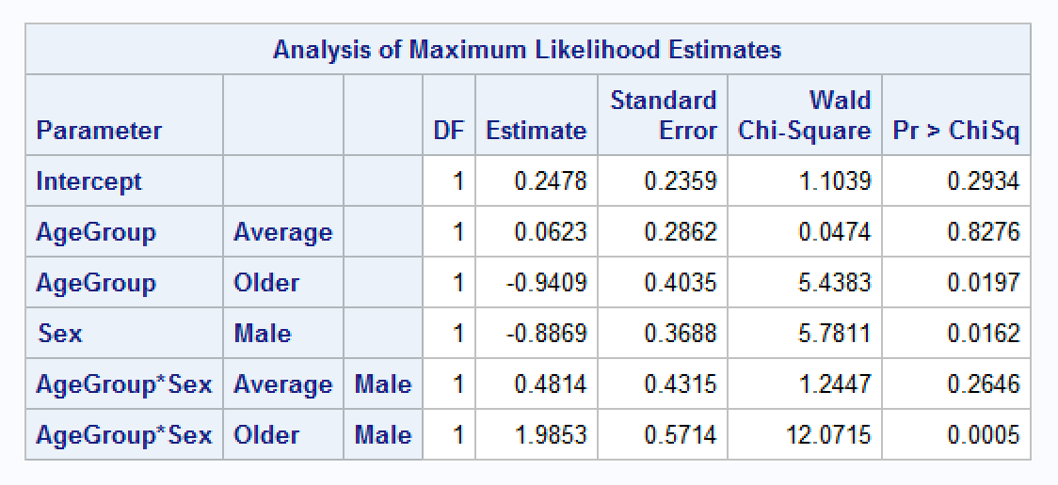
11) For males finding the best possible logistic regression model where decision is the dependent variable, and all remaining variables are possible explanatory variables. Below we also discuss below how the final model was obtained.

Using the backwards elimination, we eliminated any variables who’s p-values were over our significance level of 0.05. The variables left to build the model were AttractiveM and IntelligentM.
Since all three global tests are less than 0.05, it indicates that at least one of the variables is useful in predicting the decision of male sex (Table 11a). Pearson’s test has a p-value of 0.2827 and Deviance test has a p-value of 0.2101 which are both well over 0.05 indicating an adequate for the data.
Model Equation (Table 11b):
Logit(pie(X))hat = – 3.5092 + 0.9601X_{AttractiveM} - 0.3603X_{IntelligentM}

Table 11c shows the area under the curve which is 0.821. Table 11d shows plots that show outlier that are worth investigating.
Table 11a: Table 11b:
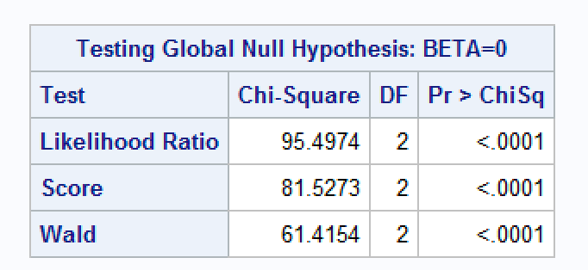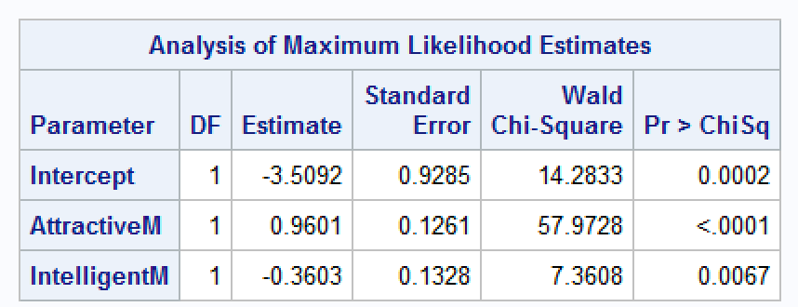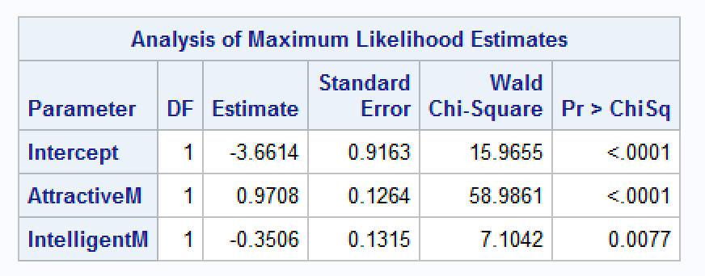
Table 11c:
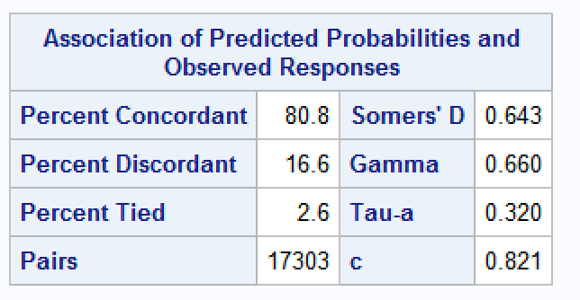
Table 11d:
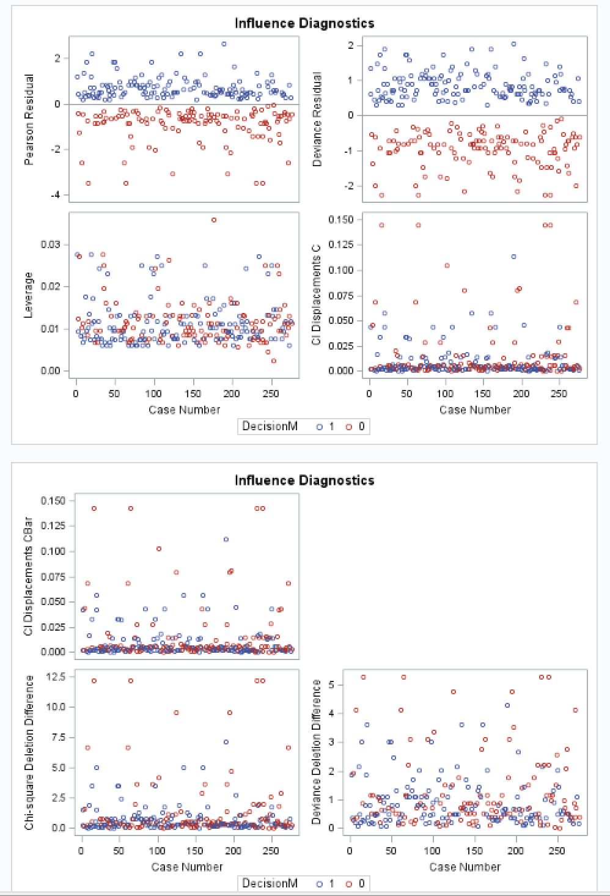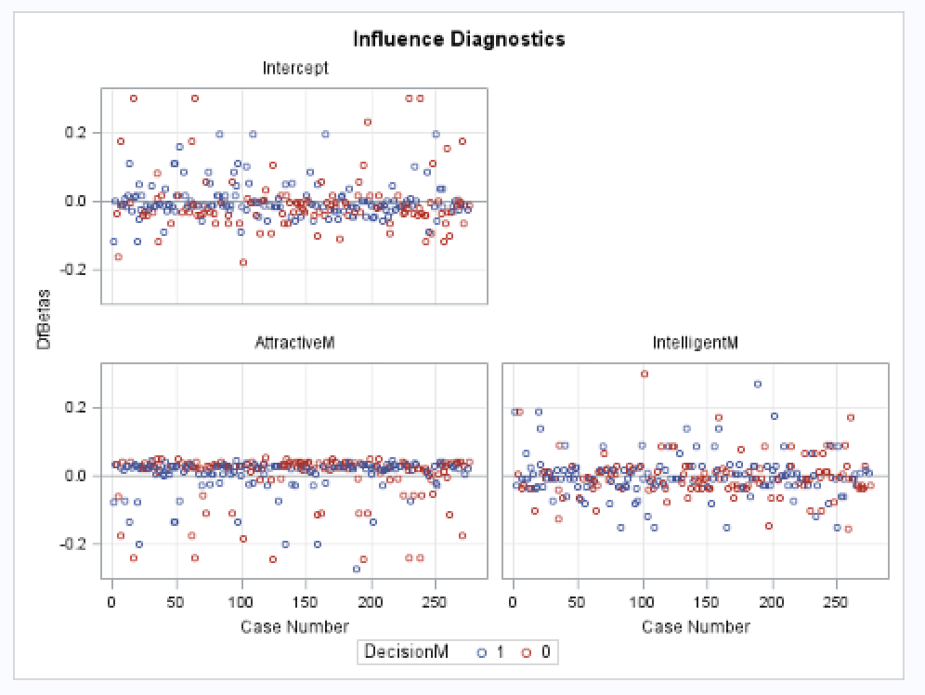
12) For females finding the best possible logistic regression model where decision is the dependent variable, and all remaining variables are possible explanatory variables. Below we also discuss below how the final model was obtained.
Using the backwards elimination, we eliminated any variables who’s p-vlaues were over our significance level of 0.05. The variables left to build the model were FunF and interestsF
Since all three global tests are less than 0.05, it indicates that at least one of the variables is useful in predicting the decision of male sex (Table 11a). Pearson’s test has a p-value of 0.3935and Deviance test has a p-value of 0.0463 which are both well over 0.05 indicating an adequate for the data.
Model Equation (Table 12b):
Logit(pie(X))hat = – 0.5421 + 0.1002X_{FunF} + 0.0117X_{SharedInterestsF}

Table 12c shows the area under the curve which is 0.563. Table 12d shows plots that show outlier that are worth investigating.

Table 12a: Table 12b:
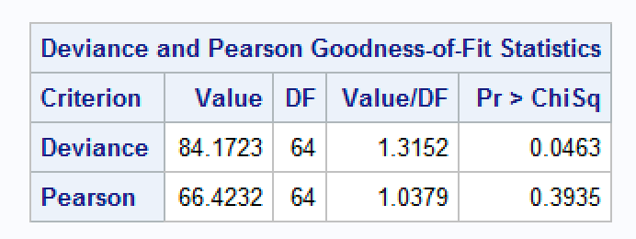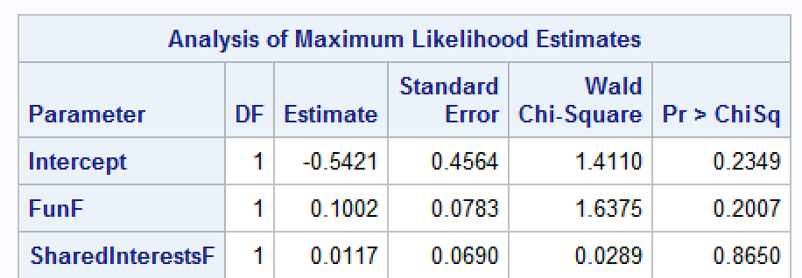
Table 12c:
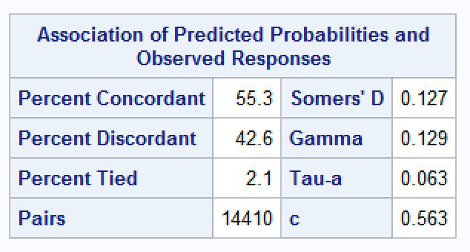
Table 12d:
